Theme Introduction:
Budgeting
COURSE TITLE:
Personal Finance
THEME TOPIC:
Budgeting
GRADE LEVEL:
10-12

Missouri Competencies:
I.3: Relate taxes, government transfer payments, and employee benefits to disposable income.
MM.1: Explain how limited personal financial resources affect the choices people make.
MM.2: Interpret the opportunity costs of financial decisions.
MM.3: Evaluate the consequences of personal financial decisions.
MM.7: Design a financial plan (budget) for earning, spending, saving, and investing.

Theme Rationale:
When people learn budgeting vocabulary and skills early, they are likely to be successful money managers. Good financial management skills require the abilities to establish a budget and understand the trade-offs required to adhere to a budget. Students must learn to apply budgeting skills as they enter the working world if we they are to be successful in managing their income.

Essential Questions:
- How does budgeting help consumers balance income, spending and savings goals?

Instructional Objectives in This Unit:
A: Explain how scarcity affects economic decisions. (MM.1)
B: Prioritize personal and financial goals. (MM.1)
C: Construct a plan to achieve those goals. (MM.1)
D: Examine current saving and spending behaviors and patterns. (MM.2, MM.3)
E: Identify key terms such as gross pay, net pay, deductions and benefits. (I.3)
F: Explain the types of benefits provided by employers. (I.3)
G: Distinguish between required and optional deductions. (I.3)
H: Identify key terms such as disposable income, variable, fixed and period expenses.
- Complete a W-4 form. (I.3)
- Identify the various designations on a paycheck/stub. (I-3)
- Analyze a W-2 statement. (I.3, MM.7)
I: Develop a budget. (MM.7)
Instructional Components

Summary:
SCHEDULE: | NUMBER OF CLASSES:
50-min Period | 10 Class Periods
90-min Period | 6 Class Periods
120-min Period | 5 Class Period
Also consider the enclosed lesson activity recommendations. Instructional objective
references are included for each lesson.
- Pretest and post test with record sheet.
- CSI lesson 6: Family Budget Forensics.

Sample Pretest and Post Test:
These tests are intended only as sample questions to assess student mastery, not as end-of-unit exams, nor are the questions representative of the state’s end-of-course exam for Personal Finance. Some questions require higher order thinking skills. The accompanying record sheet is designed to help teachers compare student mastery throughout a course before and after instruction.
Forms for the test can be found at the following web sites:
http://www.irs.gov/pub/irs-pdf/fw4.pdf and
http://www.core-ct.state.ct.us/employee/stuffer/new_paycheck.pdf.

Technology Integration:
Keep in mind that as you locate and use websites, updates can change links and availability of information. Check any website you plan to use BEFORE sending students to it.
- Use search words for articles and calculators: budgeting, budget calculators, net worth statement, income tax.
- Possible web sites:
  - www.money.com
  - www.usaweekend.com
  - www.irs.gov (forms and publications link)
  - www.taxfoundation.org
  - www.hrblock.com/tax-center/index.html
  - www.taxcut.com (tax tips and withholding calculator)
  - www.smartmoney.com/tax
  - www.yahoo
Note: Many search engines have links to tax tips, especially in the spring.
Reading and Writing Resources:
- Track spending, income and saving patterns by completing a tracking sheet for a month.
- Develop budgets and use decision-making skills to determine how to adapt and change budgets.
- Prepare personal income statements.
- Complete a property inventory (to use with net worth statement and later with insurance projects). Have students inventory their living spaces for current list.
- Complete employment related forms.
- Do federal and state income tax forms using given scenarios or student’s own information.

Higher Order/Critical Thinking Instructional Strategies:
CSI 6 Assignment – (planning and evaluating plan)

Key Vocabulary:
- Asset
- Balanced budget
- Budget
- Budget deficit
- Budget surplus
- Financial plan
- Fixed expense
- Liabilities
- Net worth statement
- Purchasing power
- Save
- Saving
- Savings accounts
- Scarcity
- Variable expense

Instructional Objectives in This Theme:
Using the Activities Chart:
MATCH ACTIVITIES TO THE MISSOURI PERSONAL FINANCE INSTRUCTIONAL OBJECTIVES.
1. Lesson activity recommendations are listed alphabetically by source and activity name.
2. Web addresses (URLs) are provided for all activities found online.
3. Activities are aligned to the objectives at right, indicated by the letter designation.
4. Additional space is provided for teachers to add their own lesson activity ideas to the listing.
A: Explain how scarcity affects economic decisions. (MM.1)
B: Prioritize personal and financial goals. (MM.1)
C: Construct a plan to achieve those goals. (MM.1)
D: Examine current saving and spending behaviors and patterns. (MM.2, MM.3)
E: Identify key terms such as gross pay, net pay, deductions and benefits. (I.3)
F: Explain the types of benefits provided by employers. (I.3)
G: Distinguish between required and optional deductions. (I.3)
H: Identify key terms such as disposable income, variable, fixed and period expenses.
- Complete a W-4 form (I.3)
- Identify the various designations on a paycheck/stub (I-3)
- Analyze a W-2 statement (I.3, MM.7)
I: Develop a budget. (MM.7)

Relevant Competencies:
I.3 Relate taxes, government transfer payments, and employee benefits to disposable income.
MM.1 Explain how limited personal financial resources affect the choices people make.
MM.2 Identify the opportunity costs of financial decisions.
MM.3 Evaluate the consequences of personal financial decisions.
MM.7 Design a financial plan (budget) for earning, spending, saving, and investing.

 | Budgeting | A. | B. | C. | D. | E. | F. | G. | H. | I.
1. | Federal Reserve Bank of Dallas, Building Your Wealth:  A Beginner’s Guide to Securing Your Financial Future  http://www.dallasfed.org/ca/wealth/ |  |  |  |  |  |  |  |  | 
2. | Internal Revenue Service,  Module 1: Payroll Taxes and Federal Income Tax Withholding  http://www.irs.gov/app/understandingTaxes/jsp/hows/lp/IM01lp.jsp |  |  |  |  |  |  |  | 
3. | Internal Revenue Service,  Module 2: Wages and Tip Income  http://www.irs.gov/app/understandingTaxes/jsp/hows/lp/IM02lp.jsp |  |  |  |  |  |  |  | 
4. | Internal Revenue Service,  Theme 4, Lesson 1: What is Taxed and Why? http://www.irs.gov/app/understandingTaxes/jsp/whys/lp/IWT4L1lp.jsp |  |  |  |  |  |  |  | 
5. | NCEE, DVED Series, Financing Your Future,  Program 3, Lessons 1, 2 and 3  Pricing and ordering information:  http://store.ncee.net/
6. | NCEE, CD-ROM Curriculum,  Financial Fitness for Life, Lesson 7: Uncle Sam Takes a Bite  Pricing and ordering information:  http://store.ncee.net/finfitperfin2.html |  |  |  |  |  |  |  | 
7. | NCEE, CD-ROM Curriculum, Financial Fitness for Life,  Lesson 20: Managing Your Money Insurance  Pricing and ordering information:  http://store.ncee.net/finfitperfin2.html |  |  |  |  |  |  |  |  | 
8. | NEFE, High School Financial Planning Program,  Unit 3, Lesson 1: Budgeting  http://www.nefe.org/hsfppportal/includes/main/home.asp?page=26000 |  |  |  |  |  |  |  |  | 
9. | NEFE, High School Financial Planning Program,  Unit 3, Lesson 2: Consumer Spending  http://www.nefe.org/hsfppportal/includes/main/home.asp?page=26000 |  |  |  |  |  |  |  |  | 

Measuring Student Mastery
Pretest and Post Test Record Sheet – Budgeting
Student Name: | Vocabulary |  | Goal Attainment |  | Form Completion |  | Budgeting
Student Name: | QUESTIONS  1, 2, 4 & 5  Points Correct  (14 pts.) | Percent Correct | QUESTIONS  2 & 3  Points Correct  (9 pts.) | Percent Correct | QUESTION 5  Points Correct  (10 pts.) | Percent Correct | QUESTION 5  Points Correct  (27 pts.) | Percent Correct
This chart could be used to record pretest and post test data collected from the pretest and post test included within this theme. Use one copy to record the pretest information and make another copy to record the post test data. Compare the points correct from the pretest with results from the post test to measure student mastery of the topics presented.
Personal Finance Pretest
Budgeting

Name: _________________________ Date: _______

Class Period: ____________________ Grade: ______

Objectives:
A: Explain how scarcity affects economic decisions. (MM.1)
B: Prioritize personal and financial goals. (MM.1)
C: Construct a plan to achieve those goals. (MM.1)
D: Examine current saving and spending behaviors and patterns. (MM.2, MM.3)
E: Identify key terms such as gross pay, net pay, deductions and benefits. (I.3)
F: Explain the types of benefits provided by employers. (I.3)
G: Distinguish between required and optional deductions. (I.3)
H: Identify key terms such as disposable income, variable, fixed and period expenses.
- Complete a W-4 form (I.3)
- Identify the various designations on a paycheck/stub (I-3)
- Analyze a W-2 statement (I.3, MM.7)
I: Develop a budget. (MM.7)

- Define scarcity and explain its effects on economy.

- Define “goal” and list 2 short-term and 2 long-term personal goals. List 2 short-term and 2 long-term financial goals.

- Create a plan to achieve one of the goals listed in your answer to the previous question.

- Define the following terms:

Gross Pay –

Net Pay –

Deductions –

Benefits –

Disposable Income –

Variable Expenses –

Fixed Expenses –

Period Expenses –

- Read the following scenario and answer the questions that relate to John’s experiences.

John Rice is at a call-back interview for an up-and-coming business in his town. He has an opportunity to ask the boss of the company questions about salary and benefits. He would like to know more about the benefits that he may be eligible for. What are 3 questions John could ask to tactfully and effectively give him some answers about benefits?

John was hired by the company with which he was interviewing. Now, he must fill out a W-4 form. Use the attached form and fill it in using John’s name and ID # 123-45-6789, fill out the rest of the form using your personal information (address, phone, etc.).

Also attached is a copy of John’s first pay check. Explain each item in the following list. If an item is a deduction, list how much was deducted.

Gross Pay –
Net Pay –
Health Net Charter HMO –
Fed Withholding –
Fed OASDI/EE –

John’s check is in the amount of $1,436.75. He will receive 2 checks each month for this amount. Construct a typical budget for John using his salary information, the chart and standard budgeting categories. You may use a calculator.

Budget Category: | Percent of Salary: | Amount John Can Spend:

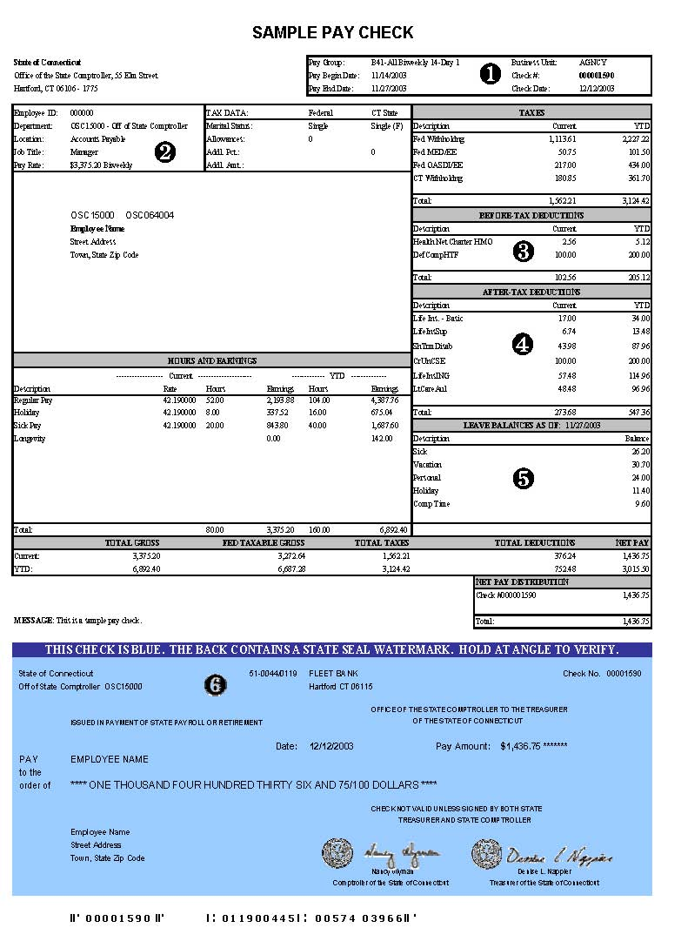
Personal Finance Post Test
Budgeting

Name: _________________________ Date: __________

Class Period: ____________________ Grade: ______/66

Objectives:
A: Explain how scarcity affects economic decisions. (MM.1)
B: Prioritize personal and financial goals. (MM.1)
C: Construct a plan to achieve those goals. (MM.1)
D: Examine current saving and spending behaviors and patterns. (MM.2, MM.3)
E: Identify key terms such as gross pay, net pay, deductions and benefits. (I.3)
F: Explain the types of benefits provided by employers. (I.3)
G: Distinguish between required and optional deductions. (I.3)
H: Identify key terms such as disposable income, variable, fixed and period expenses.
- Complete a W-4 form (I.3)
- Identify the various designations on a paycheck/stub (I-3)
- Analyze a W-2 statement (I.3, MM.7)
I: Develop a budget. (MM.7)

(1 pt for definition, 2 pts for explanation. Total 3 pts.)
- Define scarcity and explain its effects on economy.

(1 pt for definition, 1 pt for each goal. Total 5 pts.)
- Define “goal” and list 2 short-term and 2 long-term personal goals. List 2 short-term and 2 long-term financial goals.

(1 pt for each step in planning process. Total 5 pts.)
- Create a plan to achieve one of the goals listed in your answer to the previous question.

(1pt. for each term. Total 8 pts.)
- Define the following terms:

Gross Pay –

Net Pay –

Deductions –

Benefits –

Disposable Income –

Variable Expenses –

Fixed Expenses –

Period Expenses –

- Read the following scenario and answer the questions that relate to John’s experiences.

(1 pt for each question. Total 3 pts.)
John Rice is at a call-back interview for an up-and-coming business in his town. He has an opportunity to ask the boss of the company questions about salary and benefits. He would like to know more about the benefits that he may be eligible for. What are 3 questions John could ask to tactfully and effectively give him some answers about benefits?

(1 pt for each section. Total 10 pts.)
John was hired by the company with which he was interviewing. Now, he must fill out a W-4 form. Use the attached form and fill it in using John’s name and ID # 123-45-6789, fill out the rest of the form using your personal information (address, phone, etc.).

(1 pt for each. Total 5 pts.)
Also attached is a copy of John’s first pay check. Explain each item in the following list. If an item is a deduction, list how much was deducted.

Gross Pay –
Net Pay –
Health Net Charter HMO –
Fed Withholding –
Fed OASDI/EE –

(1 pt for each box completed correctly. Total 27 pts.)
John’s check is in the amount of $1,436.75. He will receive 2 checks each month for this amount. Construct a typical budget for John using his salary information, the chart and standard budgeting categories. You may use a calculator.

Budget Category: | Percent of Salary: | Amount John Can Spend:

Family Budget Forensics

The Set Up:
The Pence family currently does not have a budget for family expenses. They are a young couple who would like to starting saving for a house. Their monthly disposable income totals $2,500.00, and their monthly expenditures are shown in the table on the left. They currently have $500 in a savings account.

Current Expenditures | Dollar Amount |  | Recommended Expenditures | Percent of  Income
Short-term Saving | 0 |  | Short-term Saving | 3%
Long-term Saving | 0 |  | Long-term Saving | 7%
Housing/Insurance | $700 |  | Housing/Insurance | 31%
Food | $400 |  | Food | 15%
Car payment | $350 |  | Car payment | 12%
Car Expenses/Gasoline | $100 |  | Car Expenses/Gasoline | 4%
Utlilties | $150 |  | Utilities | 8%
TV/Cable/Dish | $100 |  | TV/Cable/Dish | 2%
Phones (2 cells) | $100 |  | Phones (2 cells) | 2%
Clothing | $175 |  | Clothing | 4%
Entertainment/  Recreation/Eating Out | $250 |  | Entertainment/  Recreation/Eating Out | 4%
Credit Card ($1200 balance) | $50 |  | Credit Card ($1200 balance) | 5%
Miscellaneous Expenses | $100 |  | Miscellaneous Expenses | 3%

The Investigation:
Unfortunately, the Pence family is not saving for any future wants. Based on the recommended expenditures in the table above right, evaluate the current expenditures of the Pence family.
Based on the recommendations, determine in which categories the family is overspending.

How could this family adjust current expenditures so that they can have money to put into both the short- and long-term saving categories?

Use the following table to solve their saving problem.

Adjusted Expenditures for the Pence Family | Dollar Amount
Short-term Saving
Long-term Saving
Housing/Insurance
Food
Car payment
Car Expenses/Gasoline
Utilities
TV/Cable/Dish
Phones (2 cells)
Clothing
Entertainment/Recreation/Eating Out
Credit Card ($1200 balance)
Miscellaneous Expenses

Write an explanation for each of your changes.
____________________________________________________________________________________________________________________________________________________________________________________________________________________________________________________________________________________________________________________________________________________________________________________________________________________________________
- Given the information about the Pence family in the above table, the category in which spending is equal to the recommended amount is:
    - clothing.
    - housing.
    - utilities.car expenses/gasoline.
    - car expenses/gasoline.utilities.
- According to their current expenditures, the Pence family is overspending by the greatest dollar amount on:
- food.
- clothing.
- car payment.
- entertainment.
- Two of the categories that the Pence family are currently under spending on include:
- housing and utilities.
- credit card payment and clothing
- utilities and food.
- phone and housing.
Think About It:
Now set up a budget for yourself. Start by creating a spending diary. Record all of your income and purchases for the next two weeks and use this information as the basis for creating a monthly budget for you to follow. (Be aware that it might take a month or two to refine your budget.)
__________________________________________________________________________________________________________________________________________________________________________________________________________________________________________________________________________________________________________________________________________________________________________________________________________________________________________________________________________________________________________________________________________________________________________________________________________________________________________________________________________________________________________________________________________________________________________________________________________________________________________________________________________________________________________________________________________________________________________________________________________________________________________________________________________________________________________________________________________________________________________________________________________________________________________________________________________________________________________________________________________________________________________________________________________________________________________________________________________________________________________________________________________________________________________________________________________________________________________________________________________
Consumer Scene Investigation Grade Sheet
CSI 6 – Family Budget Forensics

Competencies: MM.1: Explain how limited personal financial decisions affect the choices that people make.
MM.3: Evaluate the consequences of personal financial decisions.
MM.7: Design a financial plan (budget) for earning, spending, saving and investing.
Objectives: A: Explain how scarcity affects economic decisions. (MM.1)
B: Prioritize personal and financial goals. (MM.1)
C: Construct a plan to achieve those goals. (MM.1)
D: Examine current saving and spending behaviors and patterns. (MM.2, MM.3)
I: Develop a budget. (MM.7)

Answers:
1. D
2. D
3. A

Adjusted Expenditures  for the Pence Family | Dollar Amount | Possible  Answers
Short-term Saving |  | $75
Long-term Saving |  | $175
Housing/Insurance |  | $775
Food |  | $375
Car payment |  | $300
Car Expenses/Gasoline |  | $100
Utilities |  | $200
TV/Cable/Dish |  | $50
Phones (2 cells) |  | $50
Clothing |  | $100
Entertainment/Recreation/Eating Out |  | $100
Credit Card ($1200 balance) |  | $125
Miscellaneous Expenses |  | $75

Name: __________________________ Date: _________

Criteria: | 4 | 3 | 2 | 1 | Total:
Budget Figures | Expenditure adjustments were correct. | There was 1 mistake in the calculations. | There were 2 mistakes in the calculations. | There were 3 or more mistakes in the calculations.
Overspending Determinants | Student looked at overspending and proposed changes that were effective and realistic. | Student looked at spending and proposed changes that could be effective. | Changes proposed were not effective or realistic. | Changes were attempted.
Budget Problem Solving | The budget problem was solved and figures are correct, effective and realistic. | The budget was solved with 1 incorrect figure; realistic but not completely effective. | The budget was solved with 2 incorrect figures; not truly effective or realistic. | The budget was attempted but had 3 or more incorrect figures causing in to be ineffective.
Reflection of Budget Changes | Student reflected on the situation and used knowledge of goal setting and budgeting in writing the rationale. | Student reflected on the situation but didn’t cover knowledge of both goal setting and budgeting. | Student reflected but the reader is unclear as to what the student knows about goal setting and budgeting. | Student made an attempt but has not learned the concepts.
Personal Budget Effectiveness | Personal budget is effective and realistic. | Personal budget has a minor flaw but could still be effective. | Personal budget is missing a major point and would not be effective. | Personal budget was attempted but could not be used.
Spending Diary | Spending diary was complete and effective for budget making. | Spending diary was missing minor pieces that would cause the budget to need editing. | Spending diary didn’t account for all of the spending. It was ineffective. | Spending diary was attempted.
Personal Budget | Calculations were correct. | One calculation was incorrect. | Two calculations were incorrect. | Three calculations were incorrect.
 |  |  |  | Total:

