Theme Introduction:
Banking Services
COURSE TITLE:
Personal Finance
THEME TOPIC:
Banking Services
GRADE LEVEL:
10-12

Missouri Competencies:
MM.8: Demonstrate how to use the services available from financial institutions.
MM.9: Analyze the role of the Federal Reserve in controlling the money supply.

Theme Rationale:
Most people in the United States use banks for a variety of services. However, millions of U.S. citizens and residents are unbanked. Banks and other financial institutions provide safety and security for consumers’ financial assets and offer an opportunity to earn interest. It is essential that students know how to access these services, understand the variety of financial institutions from which to choose and the benefits of each.

Essential Questions:
- What financial institution will best meet the needs of the individual or household?

Instructional Objectives in This Theme:
A: Identify deposit, credit and investment services offered by commercial banks, savings and loans, credit unions and brokerage firms. (MM.8)
B: Compare checking accounts from different institutions. (MM.8)
C: Prepare the following forms related to opening and maintaining a checking account: (MM.8)
- Application form.
- Deposit ticket.
- Check.
- Check register.
- Reading and reconciling a monthly statement.
D: Differentiate among various types of electronic banking services and smart cards. (MM.8)
E: Explain the roles and responsibilities of the Federal Reserve System. (MM.9)
Instructional Components

Summary:
SCHEDULE: | NUMBER OF CLASSES:
50-min Period | 10 Class Periods
90-min Period | 6 Class Periods
120-min Period | 5 Class Period
Also consider the enclosed lesson activity recommendations. Instructional objective
references are included for each lesson.
- Pretest and post test with record sheet.
- CSI lesson 7: Banking on It.

Sample Pretest and Post Test:
The included tests are intended only as sample questions to assess student mastery, not as end-of-unit exams, nor are the questions representative of the state’s end-of-course exam for Personal Finance. Some questions require higher order thinking skills. The accompanying record sheet is designed to help teachers compare student mastery throughout a course before and after instruction.
The forms for the test can be found at: http://www.practicalmoneyskills.com/english/index.php

Technology Integration:
Keep in mind that as you locate and use websites, updates can change links and availability of information. Check any website you plan to use BEFORE sending students to it.
- Use search words for relevant tips, articles, and exercises: banking services, on-line banking safety, checking accounts, Federal Reserve and identity theft prevention.
- Possible web sites:
  - www.practicalmoneyskills.com
  - www.kidsbank.com
  - www.federalreserveeducation.org/fed101
- Use spreadsheet software to complete assignments on calculating interest earnings on a variety of savings instruments as well as completing checking account registers.
- EconEdLink, online banking information.

Reading and Writing Resources:
- Read bank service fliers and fee brochures.
- Read a bank statement.
- Complete bank reconciliations (use a variety of formats).
- Read about e-banking.
- Write checks.
- Endorse checks and complete deposit slips.

Higher Order/Critical Thinking Instructional Strategies:
CSI 7 Assignment – (Evaluation and problem solving)

Key Vocabulary:
- Banks
- Canceled check
- Check
- Checkbook register
- Credit unions
- Debit card
- Demand deposit
- Endorsement
- Federal Reserve System
- Fiscal policies
- Interest
- Interest rate
- Monetary policy
- Money
- Money supply
- Overdraft
- Reconciliation
- Savings and loan association

Instructional Objectives in This Theme:
Using the Activities Chart:
MATCH ACTIVITIES TO THE MISSOURI PERSONAL FINANCE INSTRUCTIONAL OBJECTIVES.
1. Lesson activity recommendations are listed alphabetically by source and activity name.
2. Web addresses (URLs) are provided for all activities found online.
3. Activities are aligned to the objectives at right, indicated by the letter designation.
4. Additional space is provided for teachers to add their own lesson activity ideas to the listing.
A: Identify deposit, credit and investment services offered by commercial banks, savings and loans, credit unions and brokerage firms. (MM.8)
B: Compare checking accounts from different institutions. (MM.8)
C: Prepare the following forms related to opening and maintaining a checking account: (MM.8)
- Application form.
- Deposit ticket.
- Check.
- Check register.
- Reading and reconciling a monthly statement.
D: Differentiate among various types of electronic banking services and smart cards. (MM.8)
E: Explain the roles and responsibilities of the Federal Reserve System. (MM.9)

Relevant Competencies:
MM.8 Demonstrate how to use the services available from financial institutions.
MM.9 Analyze the role of the Federal Reserve in controlling the money supply.

 | Banking Services | A. | B. | C. | D. | E.
1. | EconEdLink, Online Banking  http://www.econedlink.org/lessons/index.cfm?lesson=MM271&page=teacher |  |  |  | 
2. | EconEdLink, The Role of a Bank Teller  http://www.econedlink.org/lessons/index.cfm?lesson=MM367&page=teacher | 
3. | FDIC Money Smart, CD-ROM or VHS, Module 1: Bank on It  Program and ordering information is available at:  http:www.fdic.gov/consumers/consumer/moneysmart/overview.html |  | 
4. | Federal Reserve Bank of New York, Print Comic Book  The Story of Banks Comic Book,  Ordering information (35 complimentary copies are free of charge):  http://www.newyorkfed.org/publications/result.cfm?comics=1 |  |  |  |  | 
5. | Federal Reserve Bank of St. Louis, Animated DVD and Booklet,  In Plain English: Making Sense of the Federal Reserve,  http://stlouisfed.org/publications/pleng/default.html |  |  |  |  | 
6. | Federal Reserve Banks of America, Federal Reserve Education  http://www.federalreserveeducation.org/FRED/ |  |  |  |  | 
7. | The Mint, Saving, http://themint.ncee.net/saving/index.php | 
8. | The Mint, Spending, http://themint.ncee.net/spending/index.php |  |  | 
9. | The Mint, Tracking, http://themint.ncee.net/tracking/index.php |  |  | 
10. | NCEE, CD-ROM Curriculum,  Financial Fitness for Life, Lesson 21: Banking Basics  Pricing and ordering information:  http://store.ncee.net/finfitperfin2.html
11. | NCEE, DVED Series, Financing Your Future,  Program 3, Lessons 1, 2 and 3  Pricing and ordering information:  http://store.ncee.net/
12. | NCEE, Economics Curriculum, Focus: High School Economics,  Lesson 19: Money, Interest and Monetary Policy  Pricing and ordering information:  http://store.ncee.net/focus-highschool.html |  |  |  |  | 
13. | NCEE, Curriculum for Special Needs Students,  Practical Money Skills, Lesson 6: Banking Services  http://practicalmoneyskills.com/english/at_school/teachers |  |  |  | 

Measuring Student Mastery
Pretest and Post Test Record Sheet – Banking Services
Student Name: | Institution Options |  | Form Completion |  | Federal Reserve
Student Name: | QUESTIONS  1 & 2  Points Correct  (8 pts.) | Percent Correct | QUESTION 4  Points Correct  (16 pts.) | Percent Correct | QUESTION 3  Points Correct  (4 pts.) | Percent Correct
This chart could be used to record pretest and post test data collected from the pretest and post test included within this theme. Use one copy to record the pretest information and make another copy to record the post test data. Compare the points correct from the pretest with results from the post test to measure student mastery of the topics presented.
Personal Finance Pretest
Banking Services

Name: _________________________ Date: ________

Class Period: ____________________ Grade: _______

Objectives:
A: Identify deposit, credit and investment services offered by commercial banks, savings and loans, credit unions and brokerage firms. (MM.8)
B: Compare checking accounts from different institutions. (MM.8)
C: Prepare the following forms related to opening and maintaining a checking account: (MM.8)
- Application form.
- Deposit ticket.
- Check.
- Check register.
- Reading and reconciling a monthly statement.
D: Differentiate among various types of electronic banking services and smart cards. (MM.8)
E: Explain the roles and responsibilities of the Federal Reserve System. (MM.9)

- Explain the differences (contrasts) among banks, savings and loans, credit unions and brokerage firms.

- What criteria would you look at in comparing checking account options at different financial institutions?

- What is the Federal Reserve System? Explain 3 responsibilities that this organization has.

- Complete the attached forms for this person using the following information:

Shaylo Myerson deposited a pay check on May1 that was in the amount of $225.00. She kept out $50 in cash. She already had a balance of 122.00 in her account. She wrote a check (# 1001) that same day for her cell phone bill to Cell Company that was $53.25. On May 3, Shaylo had a hair appointment in which she wrote her next check for $20.25. She wrote another check for new nail polish that was $7.33. Shaylo babysat her nephew and was given a check to deposit from her sister, Shaylin, in the amount of $20. She made the deposit on May 5. After babysitting, she went shopping and used her debit card to buy lunch, $6.50, at McDonald’s. She wrote a check to buy shoes at The Shoe Company for $20.25 and went to the bank to withdraw $10 to have some extra cash.

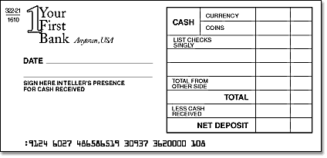

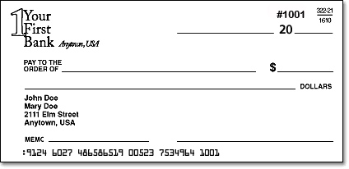

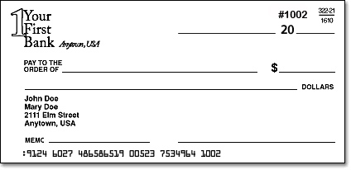

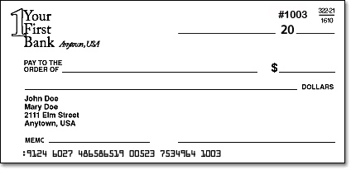

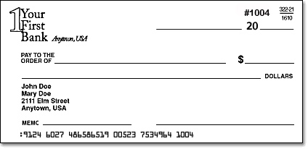

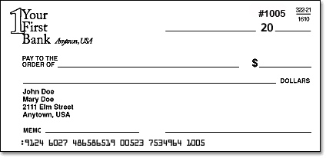

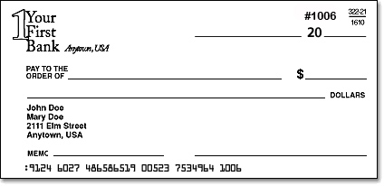

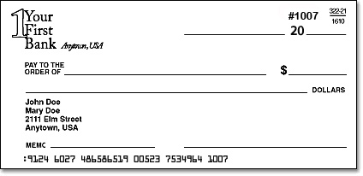

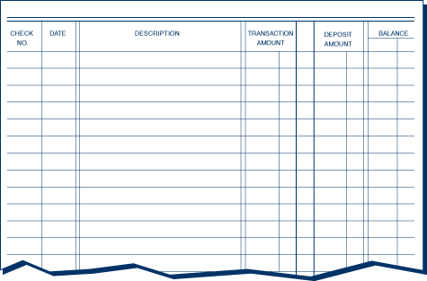

Personal Finance Post Test
Banking Services

Name: _________________________ Date: ________

Class Period: ____________________ Grade: _____/28

Objectives:
A: Identify deposit, credit and investment services offered by commercial banks, savings and loans, credit unions and brokerage firms. (MM.8)
B: Compare checking accounts from different institutions. (MM.8)
C: Prepare the following forms related to opening and maintaining a checking account: (MM.8)
- Application form.
- Deposit ticket.
- Check.
- Check register.
- Reading and reconciling a monthly statement.
D: Differentiate among various types of electronic banking services and smart cards. (MM.8)
E: Explain the roles and responsibilities of the Federal Reserve System. (MM.9)

(Must have 5 contrasts for 5 pts total.)
- Explain the differences (contrasts) among banks, savings and loans, credit unions and brokerage firms.

(Must have 3 criteria. Total 3 pts.)
- What criteria would you look at in comparing checking account options at different financial institutions?

(1 pt for definition, 1 pt each for responsibility. Total 4 pts.)
- What is the Federal Reserve System? Explain 3 responsibilities that this organization has.

(Deposit tickets 2 pts, payments 7 pts, register 7 pts. Total 16 pts.)
- Complete the attached forms for this person using the following information:

Shaylo Myerson deposited a pay check on May1 that was in the amount of $225.00. She kept out $50 in cash. She already had a balance of 122.00 in her account. She wrote a check (# 1001) that same day for her cell phone bill to Cell Company that was $53.25. On May 3, Shaylo had a hair appointment for which she wrote her next check for $20.25. She wrote another check for new nail polish that was $7.33. Shaylo babysat her nephew and was given a check to deposit from her sister, Shaylin, in the amount of $20. She made the deposit on May 5. After babysitting, she went shopping and used her debit card to buy lunch, $6.50, at McDonald’s. She wrote a check to buy shoes at The Shoe Company for $20.25 and went to the bank to withdraw $10 to have some extra cash.

Banking on It

The Set Up:
Maria Georgescu has her first job at a local gas and convenience store. She is paid every two weeks. Her employer has strongly encouraged her to open an account at a local bank and have her check automatically deposited in the account. He says that in the long run it will save her time and money because banks and other places charge fees for cashing checks for non-customers. Plus Maria must use money orders to pay bills that she can’t pay with cash, and money orders are expensive.
Maria is reluctant to open an account at the bank. Her parents moved to the United States from a country where the banking system wasn’t safe. They have never established a banking relationship and have little trust in banks. Maria’s employer and her business teacher have explained that banks in the U. S. are safe. But, Maria is still confused. At which of the five banks in her area should she open an account?

The Investigation:
Help Maria develop criteria for evaluating each of the banks in her area. Provide guidance regarding the importance of each criterion in making the decision.

Consumer Scene Investigation Grade Sheet
CSI 7 – Banking on It

Competencies: MM.8: Demonstrate how to use services available from financial institutions.
Objectives: a – Identify deposit, credit and investment services offered by commercial banks, savings and loans, credit unions, and brokerage firms. (MM.8)
b – Compare checking accounts from different institutions. (MM.8)
d – Differentiate among various types of electronic banking services and smart cards. (MM.8)

An above average answer should include the following criteria for judging a bank:
Are there fees for opening the account? How much?
Are there fees for using the account? How much?
Is online banking available? Is there a charge?
Are there ATMs conveniently located?
Is there a fee for using the ATM?
Is there a fee for using a debit card?
Is there interest paid on the account? How much?
Is there a minimum balance requirement? How large?
The most important criteria are the number and amount of fees, interest paid and the amount required to maintain a minimum balance.

Name: __________________________ Date: _________

Criteria: | 4 | 3 | 2 | 1 | Total:
Criteria for Maria to Evaluate | Criteria included all of the components; fees, online, availability, and interest. | Criteria included all of the components but could have been more thorough. | Criteria was missing minor components. | Criteria was incomplete and ineffective.
Fee Comparisons | Fees were compared realistically. Information could be used to make an effective decision. | Fees were compared but needed to be more thorough for effective selection. | Fee comparison was missing minor components. | Fee comparison was incomplete and ineffective.
Online Banking | Online banking realistic. Information could be used to make an effective decision. | Online banking services were compared but needed to be more thorough for effective selection. | Online banking services comparison was missing minor components. | Online banking services comparison was incomplete and ineffective.
Convenience/ Availability | Availability of services was realistic. Information could be used to make an effective decision. | Availability of services was compared but needed to be more thorough for effective selection. | Availability of services comparison was missing minor components. | Availability of services comparison was incomplete and ineffective.
Savings/ Investment Opportunity | Savings and investments were compared and were realistic. Information could be used to make an effective decision. | Saving and investment opportunities were compared but needed to be more thorough for effective selection. | Saving and investment opportunities comparison was missing minor components. | Savings and investment opportunities comparison was incomplete and ineffective.
Account Selection | A realistic and effective selection was made using the information that was found as well as proper decision making. | A realistic selection was made but needed to be more thorough in order to make an informed decision. Proper decision making process was used. | A decision was made but was not realistic or effective. Proper decision making process was not entirely evident. | Proper decision making was not evident. Decision was unrealistic and ineffective.
 |  |  |  | Total:

