Program of Study Template Instructions
Step 1: Open “16 Cluster Program of Study Templates – revised 8.2.11”
To “Insert School Name” for all 16 clusters
Step 2: Click on “Insert School Name” to highlight
Step 3: Click “Copy”
Step 4: Click “Replace”
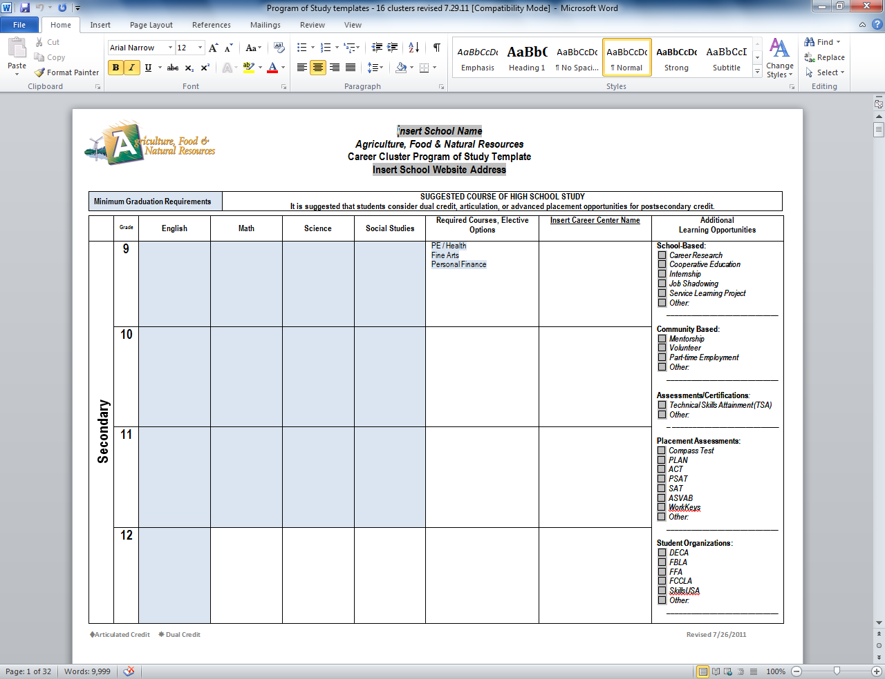
Step 2
Step 3
Step 4

Step 5: Click in the fill-in box to the right of “Find What”
Step 6

Step 6: Hold down the “Ctrl” key and type the letter “V”
“Insert School Name” should now be pasted in the “Find What” box
Step 7: Click in the fill-in box to the right of “Replace with” and type in the name of your school.

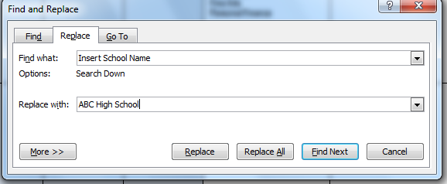
Step 8: Click “Replace All”
Step 5

Step 7

Step 8

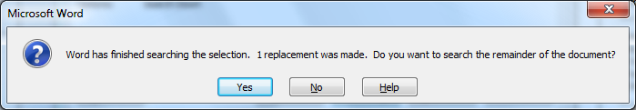
Step 9: Click “Yes”
The dialog box should indicate that 16 replacements have been made.
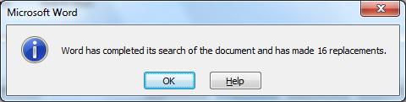
Step 10: Click “Ok” to continue.

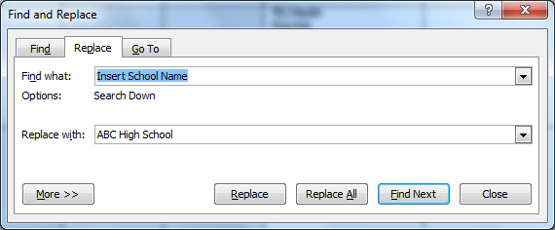
Step 11: Close the dialog box

Step 12: Repeat Steps 2 – 11 to “Insert School Web Address” and “Insert Career Center Name”
using the appropriate title to amend and replace with school information.
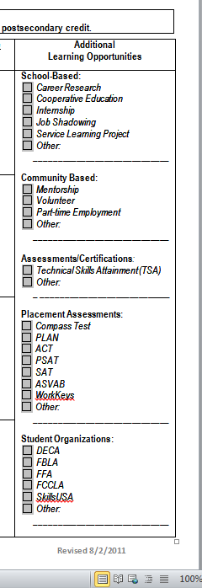
Additional Learning Opportunity Boxes
To add an “X” to a box in the Additional Learning Opportunities:
Step 1: Point to the box and Double-click

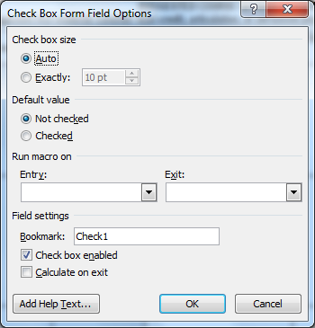
Step 2: Select “Checked”
Step 3: Click “OK”

The box should now have an “X” in it.
You will need to repeat this for each box you wish checked.
To remove an “X”, follow the same steps, but choose “Not Checked”.

Additional Items to be Completed
- Enter Graduation Requirement classes for the first cluster
  - Use the Copy and Paste feature to complete the remaining cluster templates
- Enter Required Courses, Elective Options for each cluster template
- Identify and mark Articulated and Dual Credit Classes
- Select/modify “Additional Learning Opportunities” specific to school
- Review/modify “Postsecondary Offerings” specific to school
- Review/modify “Sample Careers By Educational Level” specific to school
- Be sure to Save modified template file
- Develop a Personal Plan of Study template
  - Select from one of the state model templates, or
  - Review the Personal Plan of Study component checklist for requirements

Recommendations
- Communicate with administration and staff regarding Programs of Study, Personal Plans of Study and Career & Guidance programs and ask them to review the templates and provide feedback
- Post Program of Study templates to your school website
- Update your Course Catalog to a Career & Educational Planning Guide
  - Include Program of Study templates in the Guide
- Identify how Missouri Connections can be used in the Career Planning Process and develop a plan
- Move from “scheduling” students to developing a Personal Plan of Study with each student

