Pricing Strategies--There are many ways to price a product.

Premium Pricing.
Use a high price where there is a uniqueness about the product or service. This approach is used where a a substantial competitive advantage exists. Such high prices are chargeed for luxuries such as Cunard Cruises, Savoy Hotel rooms, and Concorde flights.
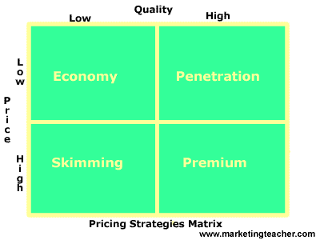

Penetration Pricing.
The price charged for products and services is set artificially low in order to gain market share. Once this is achieved, the price is increased. This approach was used by France Telecom and Sky TV.

Economy Pricing.
This is a no frills low price. The cost of marketing and manufacture are kept at a minimum. Supermarkets often have economy brands for soups, spaghetti, etc.

Price Skimming.
Charge a high price because you have a substantial competitive advantage. However, the advantage is not sustainable. The high price tends to attract new competitors into the market, and the price inevitably falls due to increased supply. Manufacturers of digital watches used a skimming approach in the 1970s. Once other manufacturers were tempted into the market and the watches were produced at a lower unit cost, other marketing strategies and pricing approaches are implemented.
Premium pricing, penetration pricing, economy pricing, and price skimming are the four main pricing policies/strategies. However, there are other important approaches to pricing.

Additional Alternative Approaches to Pricing

Psychological Pricing.
This approach is used when the marketer wants the consumer to respond on an emotional, rather than rational basis. For example 'price point perspective' 99 cents not one dollar.

Product Line Pricing.
Where there is a range of product or services the pricing reflect the benefits of parts of the range. For example car washes. Basic wash could be $2, wash and wax $4, and the whole package $6.

Optional Product Pricing.
Companies will attempt to increase the amount customer spend once they start to buy. Optional 'extras' increase the overall price of the product or service. For example airlines will charge for optional extras such as guaranteeing a window seat or reserving a row of seats next to each other.

Captive Product Pricing
Where products have complements, companies will charge a premium price where the consumer is captured. For example a razor manufacturer will charge a low price and recoup its margin (and more) from the sale of the only design of blades which fit the razor.

Product Bundle Pricing.
Here sellers combine several products in the same package. This also serves to move old stock. Videos and CDs are often sold using the bundle approach.

Promotional Pricing.
Pricing to promote a product is a very common application. There are many examples of promotional pricing including approaches such as BOGOF (Buy One Get One Free).

Geographical Pricing.
Geographical pricing is evident where there are variations in price in different parts of the world. For example rarity value, or where shipping costs increase price.

Value Pricing.
This approach is used where external factors such as recession or increased competition force companies to provide 'value' products and services to retain sales e.g. value meals at McDonalds.

PRICING WORKSHEET
Listed below are a series of pricing strategies/polices. Place them onto the correct section of the matrix.
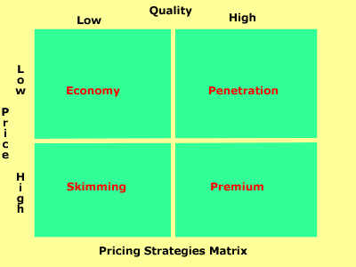
_______________ 1. Wall-Mart launch a new range of own-label soups.
_______________ 2. Cunard launch two new cruise ships.
_______________ 3. A cable TV provider moves into a new area and needs to achieve a market share.
_______________ 4. Holiday Inns try to fill hotels during winter weekends.
(This one will fall into two different ones.)
_______________ 5. Burger King introduces a new range of value meals.
_______________ 6. Nokia launch a new videophone.
7. After watching The Apprentice episode from November 25, 2010, tell me in your opinion what pricing
strategy out of the 4 main pricing strategies the women should have used to sell the watches and why
you think this would have been the most effective pricing strategy?

8. Tell me in your opinion what pricing strategy out of the 4 main pricing strategies the men should have
used to sell the purses and why you think this would have been the most effective pricing strategy?

9. Tell me in your opinion what other alternative strategy to pricing the Women used or should have used
to encourage shoppers to purchase their watches and why you think this was effective or should have
been effective?

10. Tell me in your opinion what other alternative strategy to pricing the Men used or should have used
to encourage shoppers to purchase their purses and why you think this was effective or should have
been effective?

Pricing Worksheet Key

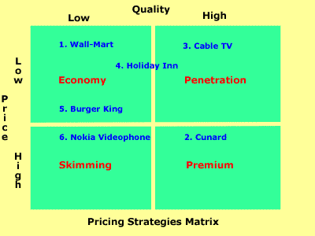
Here is the 'Pricing Strategies Matrix' with the answers overlaid. Here are the more detailed explanations.
- Wall-Mart launch a new range of own-label soups. This is an economy brand.
- Cunard launch two new cruise ships. The service is high price and high quality with a premium price.
- A cable TV provider moves into a new area and needs to achieve a market share. The company uses a penetration approach to gain market share. Prices could be increased at a later date.
- Holiday Inns try to fill hotels during winter weekends. This is an example of 'off peak' pricing.
- Burger King introduces a new range of value meals. There is a lot of price competition in the fast food market, hence the value approach.
- Nokia launch a new videophone. This is a new, innovative product that can claim a higher price. Skimming is only an option in the short-term since competition will be inevitable.

