Shoe Box Window Display

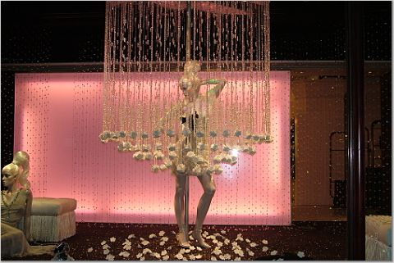

Window displays are just one component of Visual Merchandising, but as we have discussed, it can be a vital part of the pre-selling step. It has the potential to draw in prospective customers, show off new merchandise, or even sell items instantaneously. Now you have the opportunity to design your own window display for a product(s) of your choice. Design your window display in a shoe box using the following steps.

Steps/Requirements:
- Select the merchandise: must have sales appeal
- Select the type of display: one-item, line-of-goods, related-merchandise, or assortment
- Choose a setting: realistic, semi-realistic, or abstract
- Use and manipulate at least five (5) artistic elements: line, shape, color, direction, texture, proportion, lighting, or motion

After you have completed your show-box window display you will need to write a short paper over your thought process and the elements of the display. It should be typed, 12 point font. Tell me:
  - how you imagined this to look in ‘real life’
  - what store you completed this window display for. WHY?
  - the decision you made for each of the 4 requirements. WHY?

Points:
Merchandise Selected 10 points
Type of Display 10 points
Setting 10 points
Artistic Elements 25 points (5 each)
Store Chosen 5 points
Appeal/Creativity 10 points
70 points

