WHAT: An alarm clock that wakes you up with the smell and sizzle of cooking bacon.
WHY: No one likes to wake up, especially by an alarm. This clock gently wakes you up with the mouthwatering aroma of bacon, just like waking up on a Sunday morning to the smell of Mom cooking breakfast.
HOW: A frozen strip of bacon is placed in Wake n' Bacon the night before. Because there is a 10 minute cooking time, the clock is set to go off 10 minutes before the desired waking time. Once the alarm goes off, the clock it sends a signal to a small speaker to generate the alarm sound.
BACKGROUND: Waking up by force is physically and spiritually jarring, but we must do it nearly all the time. By interview and direct observation, we found a number of ways in which common alarm clocks could be improved. Many are simple conveniences, but the most essential finding was that most people eventually become "immune" to their alarms. To that end, we proposed a plug-in architecture where the alarm triggers any number of separate modules, similar to that of an electric timer with a snooze button.
Proposed add-on modules:
- Heat/Cooling unit
- Bright Lamp
- Baking unit
- Air Cannon
In addition, we propose several improvements to the clock unit itself:
- Calendar Aware: knows not to go off on weekends, holidays
- Presence Aware: only active when there is enough pressure on the bed to indicate presence of a person
- Option to have waking module "dimmed up": whether a lamp or sound or vibration is used as a waking agent, the option to have this sensation dimmed up from zero so user is eased into waking



Directions:
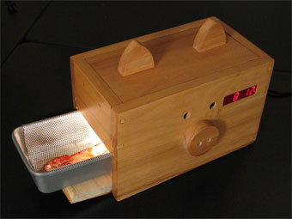
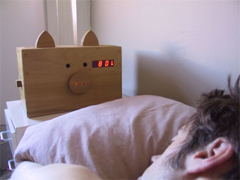
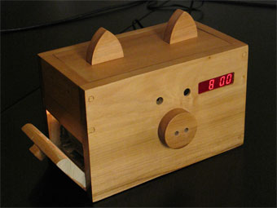
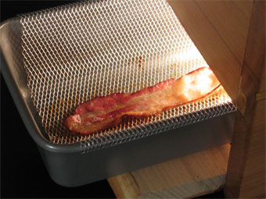
Design a package that you could use for this item. You will use the accompanying sheet to create what you want the package to look like. Below is a list of possible criteria to include on your package. You may include more if you would like. HAVE FUN AND BE CREATIVE!

- Create a creative name for the clock.
- Create a catchy slogan for the clock.
- Include product features.
- Include possible add-ons
- Include possible improvements to the clock itself.
- Write a brief description.
- Include why the consumer should want to buy this product.
- Any kind of picture or colorful artwork.

