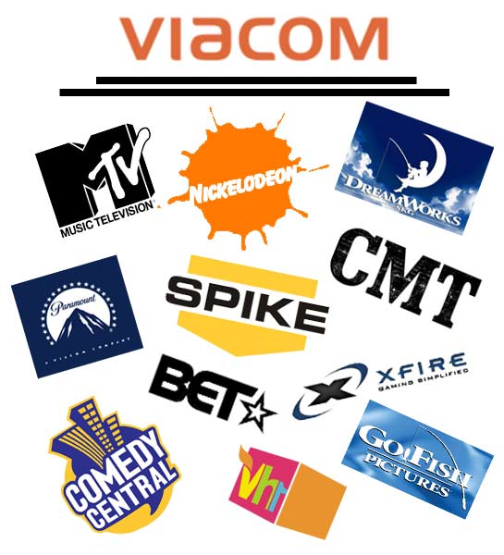

Objective:
Create a marketing plan for a new 3D division for Viacom Entertainment.
This new division must compete with Pixar, and Walt Disney Entertainment in the field of animation.

Using the following outline, write a short report answering all of the questions. After the information is compiled and the short report is complete, a PowerPoint presentation will be developed to summarize and present the information to the class.

I. Executive Summary: A summary of the marketing plan Description of the product to be marketed and associated goals. ****This section is to be completed at the end of the project.
II. Company Description:
Company Name: Give your new division (SBU) a name
Company Mission Statement: Design a mission statement for your business.

III. Operations
Company Location: Select a headquarters location for your new business

IV. Situational Analysis
Write three objectives for your new business (remember objectives must be
realistic, measurable and time specific)
Design a SWOT Analysis

V. Target Market
Who are you selling to? Consider demographics, and psychographics data
Create a customer profile for your new business.

VI. Marketing/Advertising Strategy
Design a logo and a slogan for your new business
Select the first movie that your new business will produce
Describe the movie and select the celebrity cast
Design a movie poster and a 30 -60 second radio commercial to
introduce this new movie/company

VII. Sales Strategy
Determine an opening date for your movie screening.
Select five markets/cities that you would premiere your new movie (defend your
decision)

VII. Benefits to the Client
Concluding slide. State benefits to the target market and the company proposing the
new plan.

ABOUT VIACOM

Viacom connects with our diverse audiences everywhere they are. As a leading global entertainment content company, we know what our viewers want and proudly deliver it across the globe through television, motion pictures and a wide range of digital media. Our family of prominent and respected brands includes the multiplatform properties of MTV Networks, BET Networks, Paramount Pictures and Paramount Home Entertainment.
MTV Networks includes favorites like MTV, VH1, Nickelodeon, Nick at Nite, COMEDY CENTRAL, CMT: Country Music Television, Spike TV, TV Land, Logo and approximately 155 networks around the world. In addition, digital assets such as Neopets, Xfire, Atom, Harmonix and Quizilla offer compelling and interactive content, providing an even deeper connection with our devoted and focused demographics.
BET Networks presents the best in Black media and entertainment featuring traditional and digital platforms. Brands including BET, BET J, BET Gospel, BET Hip Hop, BET.com, BET Mobile, BET Event Productions and BET International deliver relevant and insightful content to consumers of Black culture in more than 100 million households.
And with Paramount Pictures Corporation, audiences have access to a huge library of top films through brands like Paramount Pictures, Paramount Vantage, MTV Films, Nickelodeon Movies and Paramount Home Entertainment.
Fueled by our world-class brands, Viacom serves an ever-growing population of kids, tweens, teens and adults who want their favorite media and entertainment, 24/7.

3-D film?
In film, the term 3-D (or 3D or S3D is used to describe any visual presentation system that attempts to maintain or recreate moving images of the third dimension, the illusion of depth as seen by the viewer.
The technique usually involves filming two images simultaneously, with two cameras positioned side by side, generally facing each other and filming at a 90 degree angle via mirrors, in perfect synchronization and with identical technical characteristics. When viewed in such a way that each eye sees its photographed counterpart, the viewer's visual cortex will interpret the pair of images as a single three-dimensional image. Modern computer technology also allows for the production of pseudo-3D films using CGI and without the need for dual cameras.

