Magic 8 Ball Project
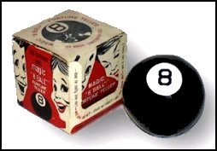
20 Points
Directions: Using HTML and JavaScript, create an online Magic 8 Ball using the following criteria as a guide and reference.
- The program must in some way ask a question and give the end user an opportunity to respond. – 10 points
- The program must then give one of the following responses. The response must be given in random fashion. 5 points
- Responses:
Ask Again Later
Better Not Tell You Now
Concentrate and Ask Again
Don't Count on It
It Is Certain
Most Likely
My Reply is No
My Sources Say No
No
Outlook Good
Outlook Not So Good
Reply Hazy, Try Again
Signs Point to Yes
Yes
Yes, Definitely
You May Rely On It

- The page must be appropriately decorated with good use of background color, text color, and graphics. – 5 points

