Unit: Soil Science AS 1

Lesson 10: Effects of Soil on Water Name
Movement and Retention

Water Retention in Different Soils

Objective: To determine why water retention is different in the two soil samples.
Activity Length: Two class periods

Materials and Equipment:
• Two 1-quart jars
• Two pieces of heavy string or twine
• Two lamp chimneys or cylinders
• Two pounds of soil samples from two sites

Procedure:

1. Take one soil sample from a garden.
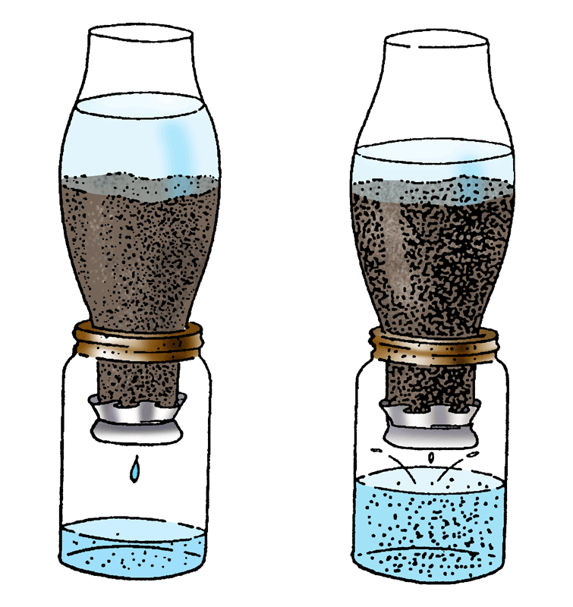
2. Take the second soil sample from a field that shows lack of organic matter.
Note: Be sure the soils are equally dry.
3. Tie a cloth over the top of each chimney.
4. Turn chimneys upside down and fill each about two-thirds full with each of the collected soil samples.
5. Place chimneys in the jars as shown.
6. Pour a pint of water into each chimney.
7. Observe the two soil samples and record how long it takes the water to begin to drip into the jars and how long the water continues to drip.
Activity | Sample #1 | Sample #2
How long did it take for water to begin to drip into the jars?
How long did the water drip from each sample?
How much of the original water passed through the soil sample?
8. Measure the amount of water that passes through each soil sample.

Unit: Soil Science AS 1 (Continued)

Lesson 10: Effects of Soil on Water Name
Movement and Retention

Water Retention in Different Soils

Key Questions:

1. Does crumbly soil take in water faster than cloddy soil? Explain why or why not.

2. What causes soil to pack together?

3. Why is organic matter important in preventing erosion?

