Unit: Soil Science AS 1

Lesson 12: Interpretations and Management of Soil Name

How Cover Crop Affects Soil Loss

Objective: To illustrate the effects of a cover crop.
Activity Length: Two class periods

Materials and Equipment:
• Two small boxes approximately 16 inches long and 12 inches wide and 4 inches deep. Make them watertight by lining with plastic, tin, or tar paper. At one end of each box, cut a V-notch 1 inch to 1-1/2 inches deep and fit with a tin spout to draw runoff water into a container (see illustration).
• Two flower sprinklers, half-gallon size
• Two half-gallon wide-mouth fruit jars
• Two 1-inch thick sticks of wood, 12 inches long

Procedure:

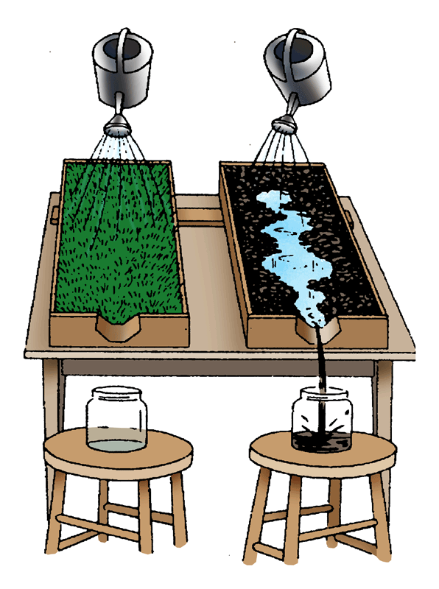
1. Cut a piece of sod from a pasture, lawn, fence, row, etc., to fit into one of the boxes. Trim the grass to about 1-inch high.

2. Fill the other box with soil from the same location, but without grass – just the soil. The strategy is to have the same kind of soil in the boxes, one with grass and one bare.

3. Set the boxes on a table so that the spouts extend over the edge.

4. Place the sticks under the inside end to create downward slope toward the edge of the table.

5. Place the empty jars under the spouts to catch runoff.

6. Fill the two sprinklers with water and pour the water on both boxes at the same time. Pour steadily and at the same rate for both boxes.
Unit: Soil Science AS 1 (Continued)

Lesson 12: Interpretations and Management of Soil Name

How Cover Crop Affects Soil Loss

Key Questions:

1. What resulted when water was applied to the box with bare soil?

2. What did you notice about the box of sod as water was applied?

3. What conclusions can you draw from this comparison?

