Unit: Soil Science AS 1

Lesson 1: Importance of Soil Name

Making Soil Artificially

Objective: Students can show how some of the forces of nature break rocks into soil material.
Activity Length: Two class periods

Materials and Equipment:
• Experiment One: Two pieces of limestone or fine sandstone rock. (If you do not have natural stone, pieces of building rocks or concrete will do.)
• Experiment Two: Six pieces of small limestone rock, hot plate, pint of ice water, and a small pan.
• Experiment Three: Small glass jar with cap, water to fill glass jar, and refrigerator with freezing compartment.
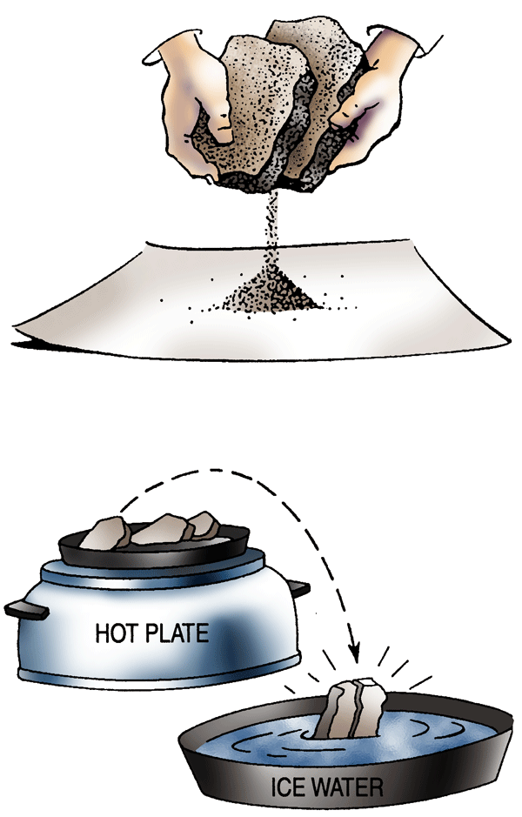
• Experiment Four: Six small pieces of limestone rock, vinegar (one pint), glass container, and hot plate.

Experiment One Procedure:
1. Rub two pieces of limestone or fine sandstone together.
2. Notice how long it takes to rub off even a few fine particles.
Conclusion: Soil is very, very slowly formed from rocks by this same rubbing together action.

Experiment Two Procedure:
(To be conducted by the instructor only. Use extreme caution. Wear safety goggles.)
1. Heat a small piece of limestone over a flame or on a hot plate.
2. Drop the limestone rock quickly into a pan of ice water.
3. Rock should break or crack as it contracts after expansion by heating.
Conclusion: Changes in temperature help make rock into soil by the heating and cooling conditions found in nature.
Expansion and contraction chips off particles of rock just as was noted when the hot limestone rock was dropped into icy water.

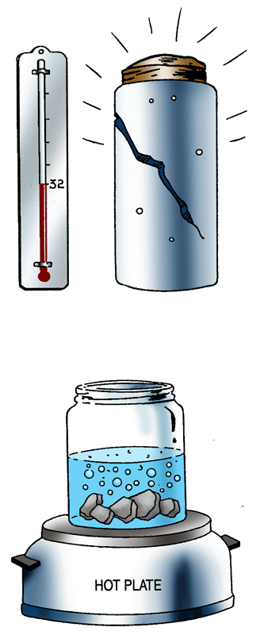
Experiment Three Procedure:
1. Fill a small discarded glass jar with water and cap it tightly.
2. Place the jar in the freezer compartment of a refrigerator and allow it to freeze.
3. What happened to the jar?
Conclusion: Freezing water expands with tremendous force. Water finds its way into cracks in a rock and freezes. Expansion by freezing water causes the rock to crack or break and continues the process of turning rocks into smaller and smaller pieces.

Experiment Four Procedure:
(To be conducted by the instructor only. Use extreme caution. Wear safety goggles.)
1. Place limestone rocks in a tempered glass container.
2. Fill glass container about half full of vinegar.
3. Heat the vinegar on a hot plate and notice how bubbles form on the pieces of limestone.
Conclusion: Bubbles are carbon dioxide gas made from carbon and oxygen being released from the limestone by a chemical change in the rock. This chemical change is caused by the acid in the vinegar. By putting limestone into the vinegar, you are duplicating in a small way what plants do in breaking down rocks.
Carbon dioxide gas released from plants dissolves in soil moisture creating a weak carbonic acid. This carbonic acid acts upon the rocks in a similar way to the vinegar only in a much, much slower manner.

Unit: Soil Science AS 1 (Continued)

Lesson 1: Importance of Soil Name

Making Soil Artificially

Key Questions:

1. Explain what action takes place when limestone rocks are heated and dropped into ice water.

2. What chemical reaction takes place when limestone rock is placed in vinegar?

3. Explain how freezing and thawing break up large rocks.

