Unit: Soil Science AS 1

Lesson 4: Soil Texture Name

Are All Soil Particles the Same Size?

Objective: To observe the amount of sand, silt, and clay in three soil samples.
Activity Length: Two class periods

Materials and Equipment:
• Three quart jars with lids
• Soil samples
• Water
• Paper and pencil or markers

Procedure:

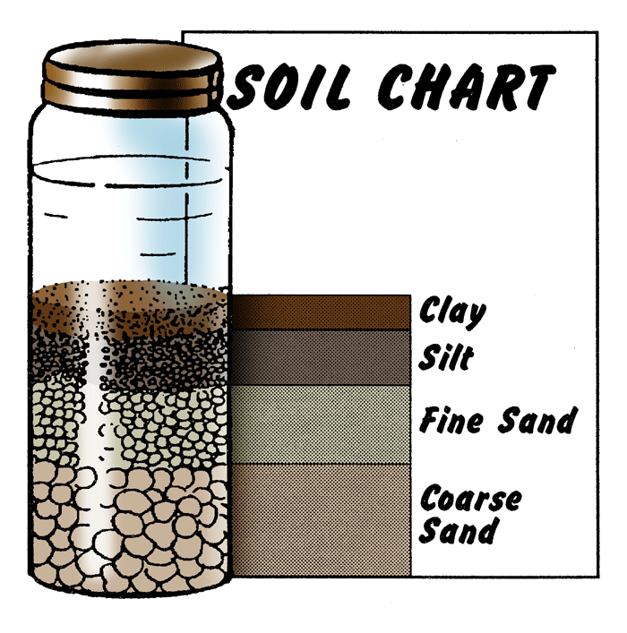
1. Obtain three soil samples from different locations.
2. Fill three quart jars about two-thirds full of water.
3. Place one soil sample in each jar. Place lid on jars and hand tighten.
4. Shake each jar vigorously.
5. Place jars on table and let the soil settle.
6. Allow a 24-hour period of time for the soil to completely settle.
7. Place an index card or heavy stock paper beside each jar and draw a diagram showing different layers for each soil sample.
8. Label each layer of each sample.
9. Observe each soil sample and record the information in the table below. Measure and record the amount of sand, silt, and clay.

Soil Type | Sample #1 | Sample #2 | Sample #3
Coarse Sand
Fine Sand
Silt
Clay
Unit: Soil Science AS 1 (Continued)

Lesson 4: Soil Texture Name

Are All Soil Particles the Same Size?

Key Questions:

1. Which samples will hold the most water?

2. What sample has the most open space between the soil particles?

