Unit: Soil Science Name

Lesson 4: Soil Texture Date

Evaluation

Directions: Match the definition on the left with the term on the right.

_____ 1. Relative percentages of sand, silt, and clay in the soil
a. Fine Earth
b. Texture
c. Cobblestone
d. Sand
e. Coarse fragment
f. Droughty
g. Clay
h. Porosity
i. Silt
j. Pore space
_____ 2. Inability of a soil to store enough water to meet plant requirements
_____ 3. The total amount of pore space in a soil
_____ 4. Portion of soil not occupied by solid material but which is filled with water or air
_____ 5. Largest of the soil separates, between 0.05 and 2.00 mm in diameter
_____ 6. Medium-sized soil separate, particles between 0.05 and 0.002 mm in diameter
_____ 7. The class of smallest soil particles, smaller than 0.002 mm in diameter
_____ 8. Individual particles that are larger than 2 mm in diameter
_____ 9. A coarse fragment, or piece of rock in the soil, which is between 3 and 10 inches in size
_____ 10. All particles smaller than 2 mm in diameter

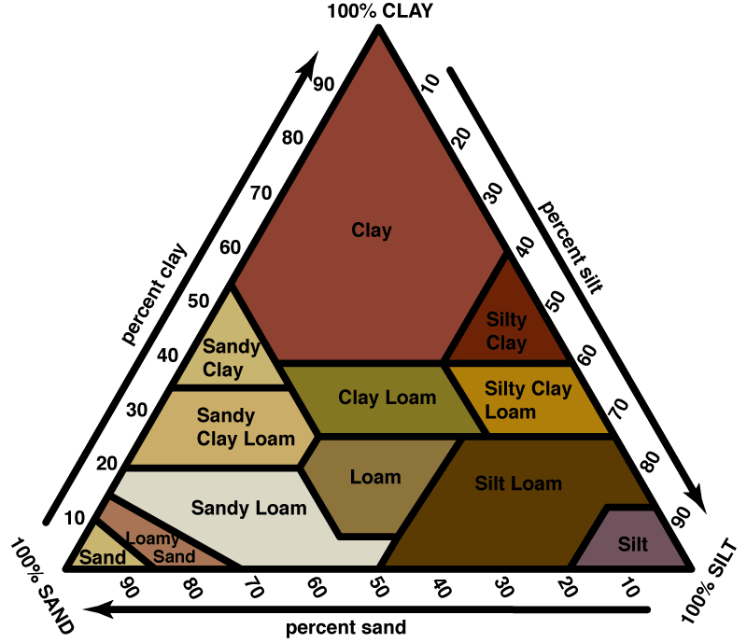

11. Use the soil triangle to determine the correct name for the texture of a soil sample that is 40% sand, 15% clay, and 45% silt.
The soil is a ______________________.

