Unit: Soil Science Name

Lesson 4: Soil Texture Date

Evaluation

Directions: Match the definition on the left with the term on the right.

b 1. Relative percentages of sand, silt, and clay in the soil
a. Fine Earth
b. Texture
c. Cobblestone
d. Sand
e. Coarse fragment
f. Droughty
g. Clay
h. Porosity
i. Silt
j. Pore space
f 2. Inability of a soil to store enough water to meet plant requirements
h 3. The total amount of pore space in a soil
j 4. Portion of soil not occupied by solid material but which is filled with water or air
d 5. Largest of the soil separates, between 0.05 and 2.00 mm in diameter
i 6. Medium-sized soil separate, particles between 0.05 and 0.002 mm in diameter
g 7. The class of smallest soil particles, smaller than 0.002 mm in diameter
e 8. Individual particles that are larger than 2 mm in diameter
c 9. A coarse fragment, or piece of rock in the soil, which is between 3 and 10 inches in size
a 10. All particles smaller than 2 mm in diameter

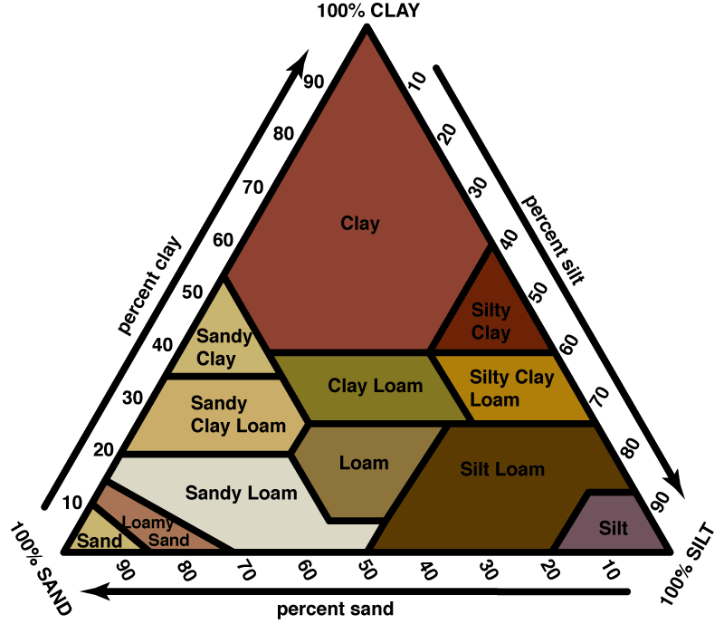

11. Use the soil triangle to determine the correct name for the texture of a soil sample that is 40% sand, 15% clay, and 45% silt.
The soil is a ______________________.
Correct answer is loam.

