Unit: Soil Science Name

Lesson 6: Soil Horizons Date

Evaluation

Directions: Match the definition on the left with the term on the right.
a. Pedon
b. Profile
c. Horizon
d. Organic matter
e. Transitional horizon
f. Parent material
g. Weathering
h. Erosion
i. Leaching
j. Saturated
_____ 1. Gradual changes from one master horizon to another

_____ 2. The smallest volume that can be called soil

_____ 3. Removal of soluble minerals from the soil by movement of water through the soil over long periods of time

_____ 4. A layer of soil that is approximately parallel to the earth’s surface

_____ 5. The changing of rocks into soils

_____ 6. The sum of all plant and animal material, living or dead, that is mixed into the soil

_____ 7. When all the pores of a soil are full of water

_____ 8. A vertical section of soil that allows you to see all the horizons that are present

_____ 9. The original geologic material from which the horizons of a soil are formed

_____ 10. Loss of valuable topsoil by the action of wind or water

Directions: Match the correct horizon to the soil profile. a. R horizon
b. O horizon
c. C horizon
d. A horizon
e. B horizon
f. E horizon
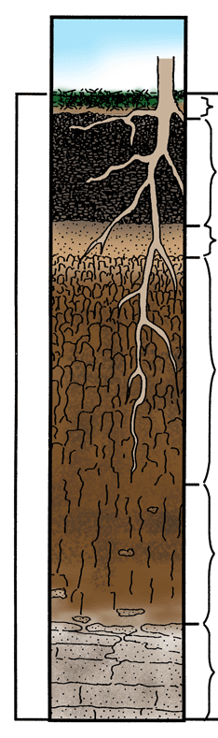
11. _______
12. _______
13. _______
14. _______
15. _______
16. _______

