Unit: Soil Science Name

Lesson 6: Soil Horizons Date

Evaluation

Directions: Match the definition on the left with the term on the right.
a. Pedon
b. Profile
c. Horizon
d. Organic matter
e. Transitional horizon
f. Parent material
g. Weathering
h. Erosion
i. Leaching
j. Saturated
e 1. Gradual changes from one master horizon to another

a 2. The smallest volume that can be called soil

i 3. Removal of soluble minerals from the soil by movement of water through the soil over long periods of time

c 4. A layer of soil that is approximately parallel to the earth’s surface

g 5. The changing of rocks into soils

d 6. The sum of all plant and animal material, living or dead, that is mixed into the soil

j 7. When all the pores of a soil are full of water

b 8. A vertical section of soil that allows you to see all the horizons that are present

f 9. The original geologic material from which the horizons of a soil are formed

h 10. Loss of valuable topsoil by the action of wind or water

Directions: Match the correct horizon to the soil profile. a. R horizon
b. O horizon
c. C horizon
d. A horizon
e. B horizon
f. E horizon
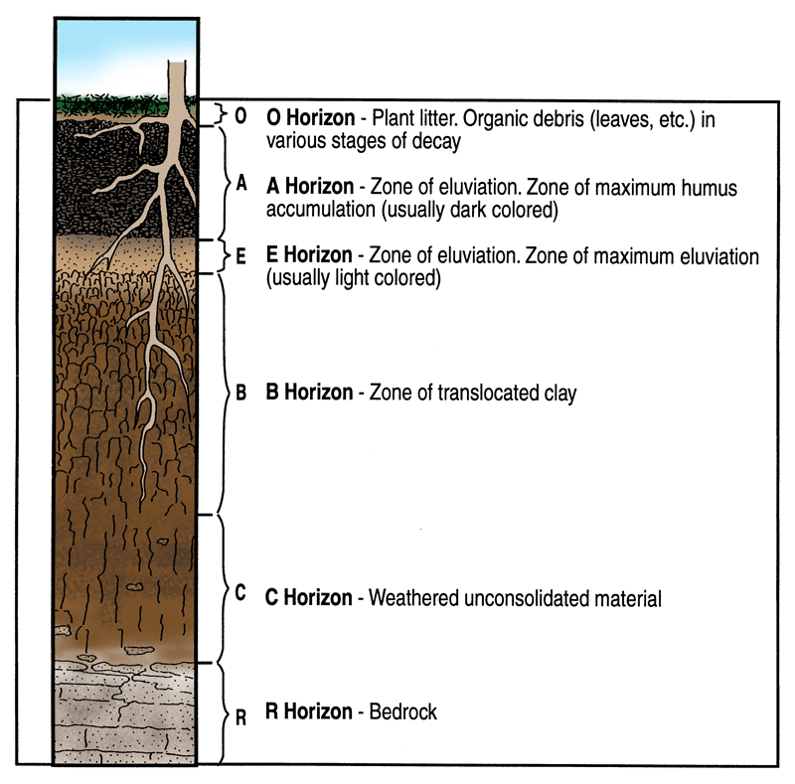
11. ___b____
12. ___d____
13. ___f____
14. ___e____
15. ___c____
16. ___a____

