Unit: Soil Science AS 1

Lesson 8: Soil Fertility Name

How Organic Matter Builds Soil Structure

Objective: To determine why the organic matter content is so important to improving the tilth of the soil and water holding capability.
Activity Length: Two class periods

Materials and Equipment:
• Two wide mouth glass jars
• Wire
• Soil samples

Procedure:
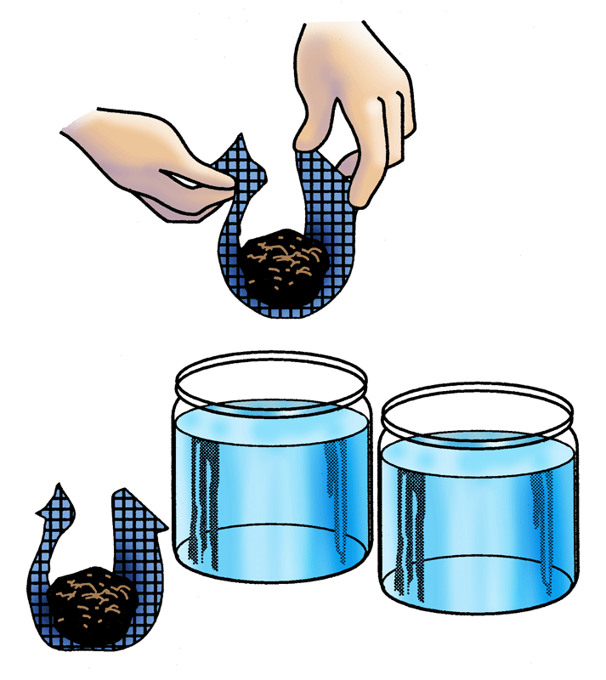
1. Bend the wire as shown in the illustration, so that it extended basketlike down into the jar.
2. Collect lumps of soil (not sandy) just under the sod from 1) and undisturbed fence row and 2) a cultivated field.
3. The lumps should be about twice the size of an egg.
4. Fill the jars with water to within an inch of the top.
5. Place the lumps of soil in the basket and lower them gently into the jars.
6. Watch closely and make notes of what happens.

Sample | Time for Sample  to Fall Apart | Which Sample  Took Water Faster
Cultivated field
Undisturbed fence row

Unit: Soil Science AS 1 (Continued)

Lesson 8: Soil Fertility Name

How Organic Matter Builds Soil Structure

Key Questions:

1. Why did the soil from the heavily cultivated field fall apart?

2. Why did the soil from the undisturbed fence row hold its shape and not fall apart?

