CAREER EDUCATION COORDINATORS (CECs)
Promote and enhance the career development process in the State of Missouri
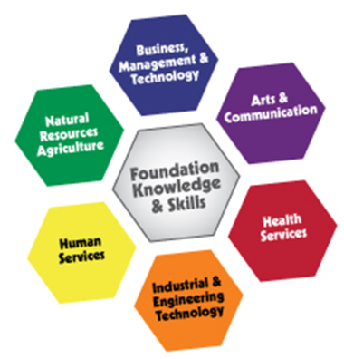
Services available through regional CECs
- K-12 Career Development
  - Professional development on the career development process
  - Career education resources and materials available online
  - Facilitate implementation of a comprehensive career development process
    - Career Awareness – Elementary
    - Career Exploration – Middle School
    - Career Planning and Decision Making – High School
  - Program of Study/Personal Plan of Study/Career &Educational Planning Guide template development/facilitation
  - Assist middle and high schools in developing a school-wide process for the development, review and revision of personal plans of study
  - Promote programs and opportunities provided at area career centers

- Guidance System of Support for School Counselors
  - Consortium meetings held at area career centers

- Awareness, Recruitment and Retention of Nontraditional Students in Career Education Programs
  - Support services to students enrolled in nontraditional programs
  - STEM Equity Pipeline Project
  - Assist in use of data focusing on Perkins funding indicators relative to nontraditional participation and completion
  - Breaking Traditions Award competition

- Missouri Connections
  - Support integration/implementation of Missouri Connections into Grades 6 – 12
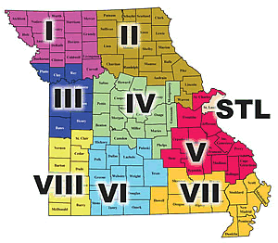
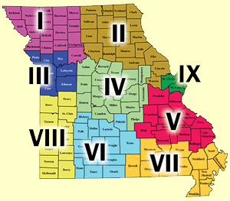
For information contact your
Regional Career Education Coordinator at

www.missouricareereducation.org/for/cec

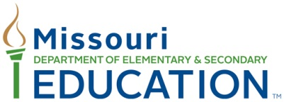
Regional Career Education Coordinators
Region I - Northwest Missouri
Region II - Northeast Missouri
Region III - Greater Kansas City Area
Region IV - Central Missouri
Region V – East Central Missouri
Region VI - South Central Missouri
Region VII - Southeast Missouri
Region VIII - Southwest Missouri
Region IX – Greater St. Louis Area

Charlene Piel  Region I - Northwest Missouri  Hillyard Technical Center  3434 Faraon Street  St. Joseph, MO 64506-5100  Ph: (816) 671-4170, ext. 154  Fax: (816) 671-4479  charlene.piel@sjsd.k12.mo.us | Lois Powell  Region II - Northeast Missouri  Kirksville Area Technical Center  1103 S. Cottage Grove  Kirksville, MO 63501  Ph: (660) 665-2865 ext. 53  Fax: (660) 626-1477  lpowell@kirksville.k12.mo.us
Lori Mann  Region III - Greater Kansas City Area  Northland Career Center  1801 Branch St.  Platte City, MO 64079  Ph: (816) 718-0256  Fax: (816) 858-3278  mannl@platteco.k12.mo.us | Janet Bagby  Region IV - Central Missouri  Columbia Career Center  4203 South Providence  Columbia, MO 65202  Ph: (573) 214-3800  Fax: (573) 214-3801  jbagby@columbia.k12.mo.us
Tanya DeGonia  Region V – East Central Missouri  Mineral Area College  P.O. Box 1000  Park Hills, MO 63601  Ph: (573) 518-2255  Fax: (573) 518-2163  tdegonia@mineralarea.edu | Michele Charlebois-Didreckson  Region VI - South Central Missouri  Ozark Technical Community College  1001 E. Chestnut Expressway  Springfield, MO 65802  Ph: (417) 447-6970  Fax: (417) 447-6906  charlebm@otc.edu
Camille MacDonald  Region VII - Southeast Missouri  Poplar Bluff Technical Career Center  3203 Oak Grove Road  Poplar Bluff, MO 63901  Ph: (573) 785-2248  Fax: (573) 785-4168  cmacdona@pb.k12.mo.us | Beth Garrett-Dillon  Region VIII - Southwest Missouri  Scott Regional Technology Center  Two David Sippy Drive  Monett, MO 65708  Ph: (417) 235-7369  Fax: (417) 235-8270  bdillon@monett.k12.mo.us
Michelene Moeller
Region IX – Greater St. Louis Area
Lewis and Clark Career Center
2400 Zumbehl Road
St. Charles, MO 63301
Ph: (636) 443-4955
Fax: (636) 443-4951
mmoeller@stcharlessd.org

