(Smartboard Activity)
Economic Impact of the World Series – St. Louis Cardinals 2006 and 2011

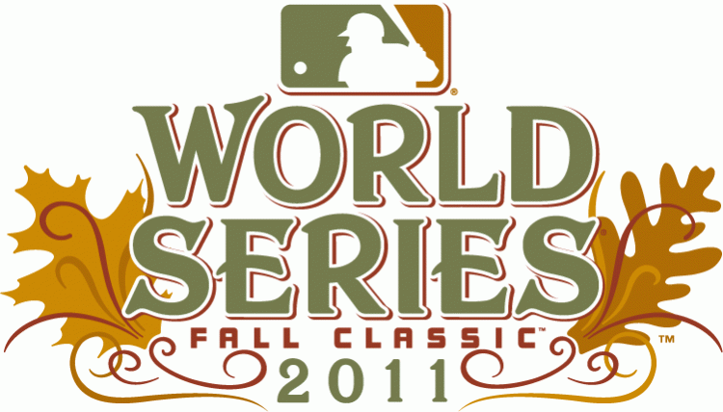

Optional Activities: Assign students to write 1-2 paragraphs regarding their thoughts to the economic impact of the World Series and then complete this activity.
Student Answers: Book Answers (page 19):
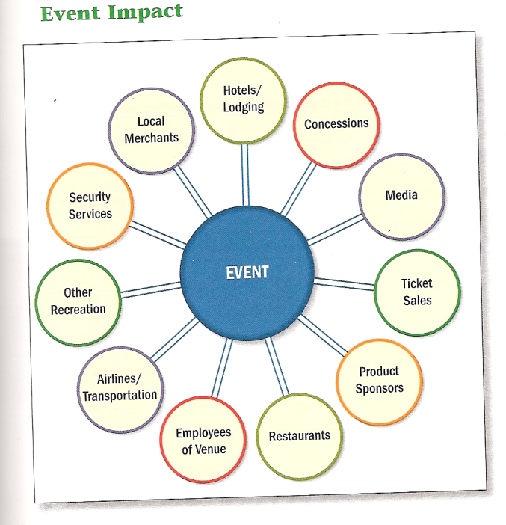
- Rally Squirrel
- Next year’s ticket sales
- Bar/Restaurant profits
- Parking profits
- Metrolink extra trains
- World Series apparel
- TV/radio commercials
- Hotel profits increased

Created by: Oakville High School
Business Department

Submitted by: Stacey Anderson

